**Experiment Number-1**

Submitted by: Name: MD SAIFUL ISLAM ID: 18-36363-1 Course: Digital Electronic

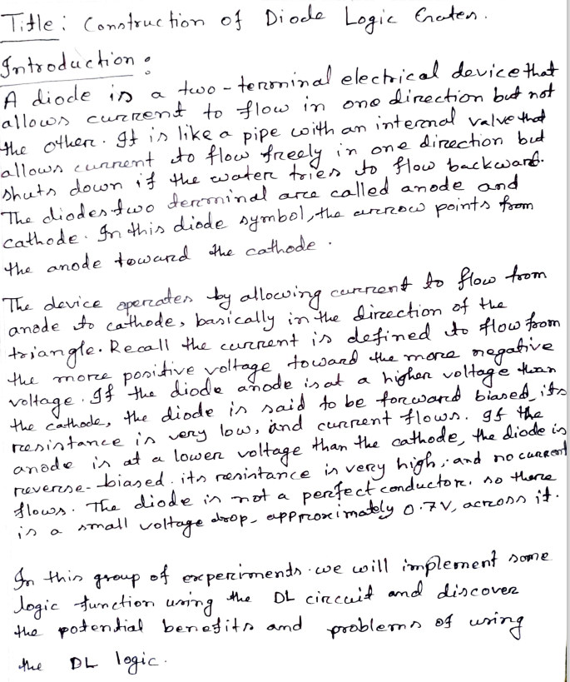

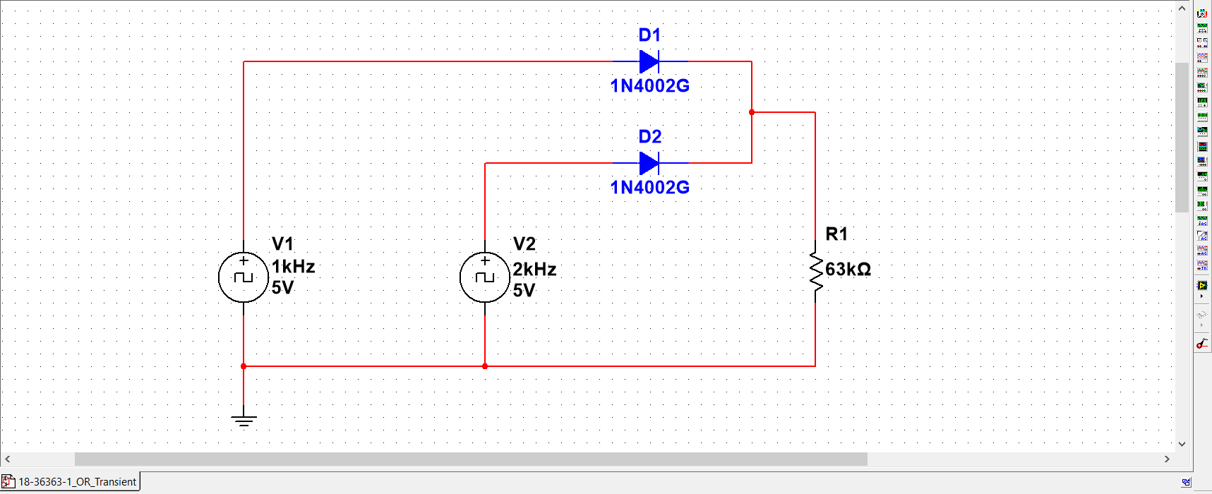**Block Diagram:**

Figure 1: DL-OR Gate

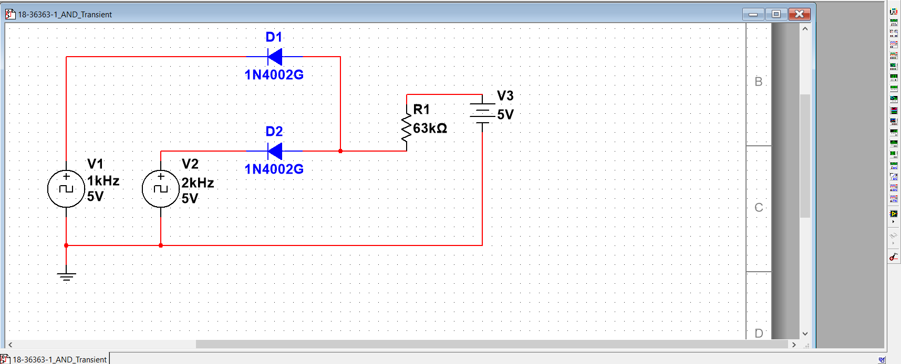

Figure 2: DL-AND Gate

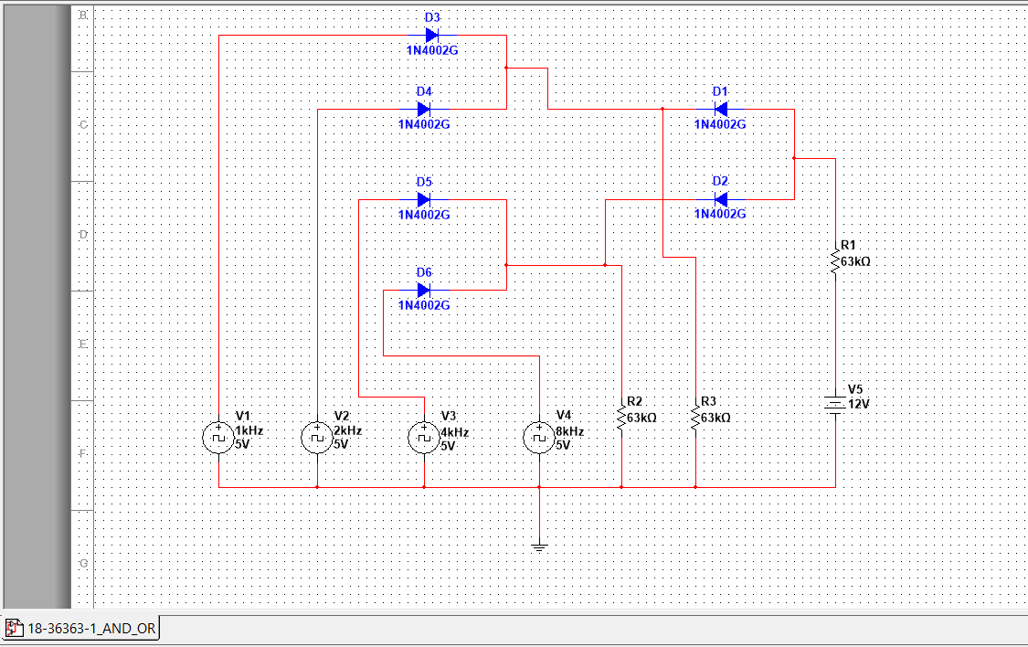

Figure 3: DL-AND-OR Gate

**Graph:**

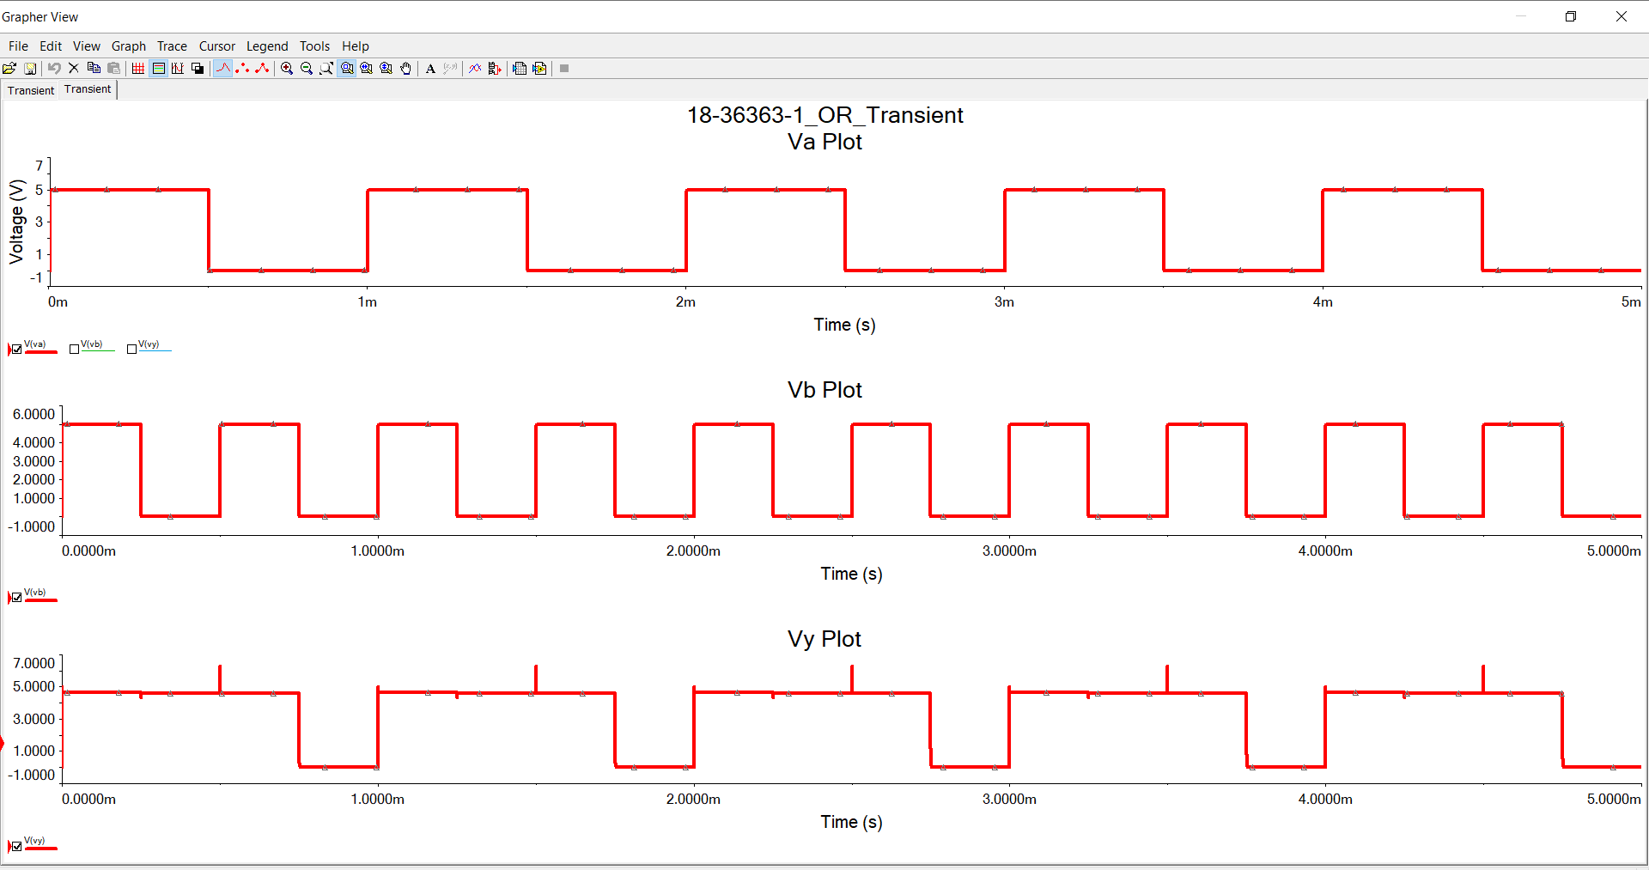

Figure 4: DL-OR Gate Graph

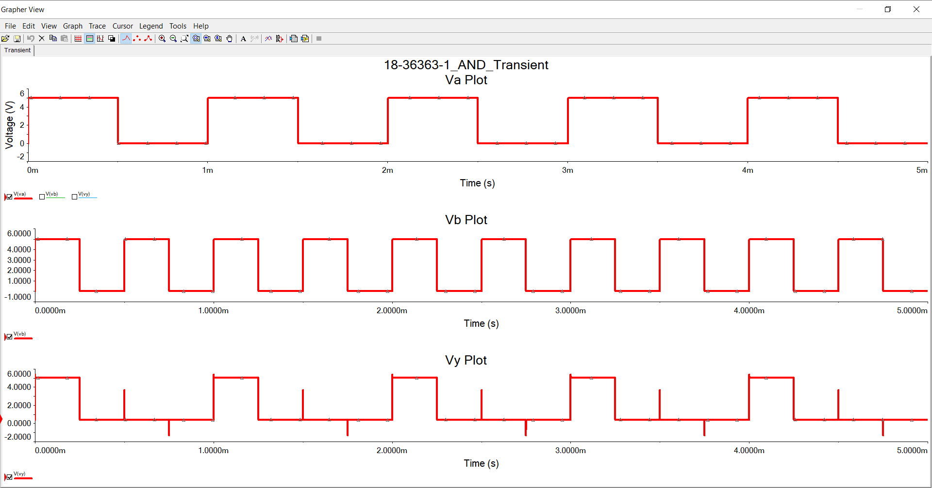

Figure 5: DL-AND Gate Graph

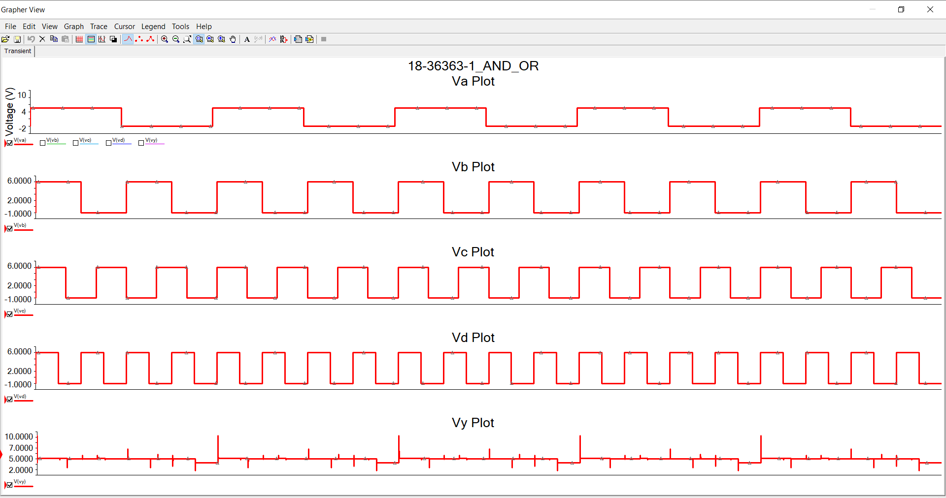

Figure 6: DL-AND-OR Gate Graph

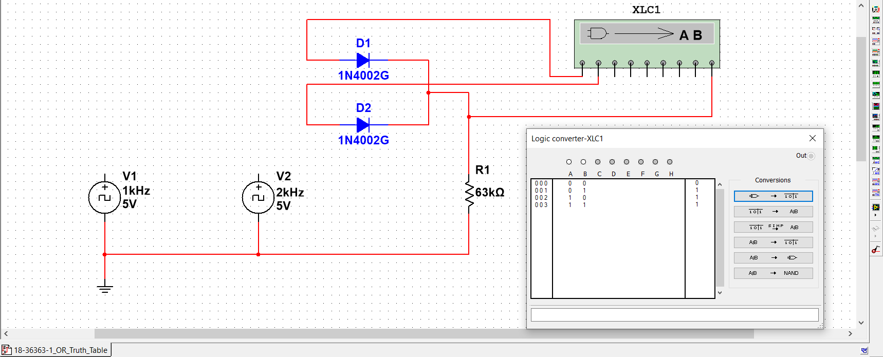**TruthTable:**

Figure 7: DL-OR Gate Truth Table.

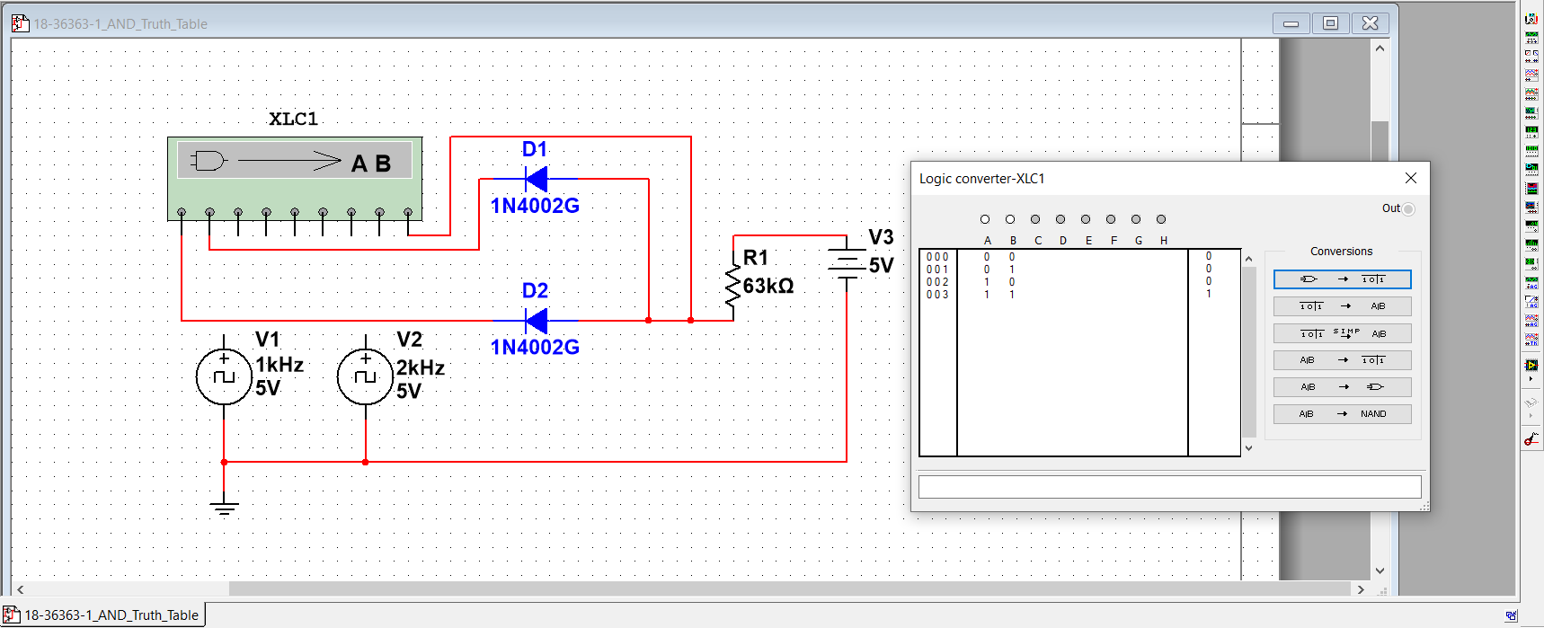

Figure 8: DL-AND Gate Truth Table.

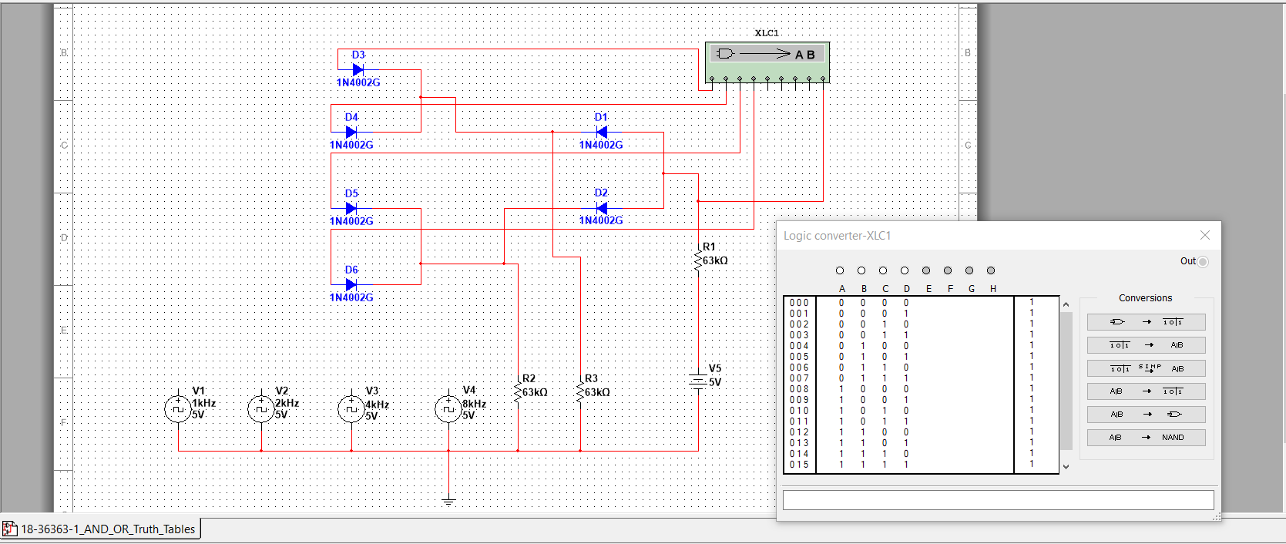

Figure 9: DL-AND-OR Gate Graph

